



***‘Help us Steven Price you’re our only hope’*** – Ernesto Parra

|  |  |  |
| --- | --- | --- |
| **Table of Contents**  [1 Game Overview](https://n-xovwktmtjsnaxyc2mwes2xu7pohqedmdm6zjw5q-2lu-script.googleusercontent.com/userCodeAppPanel)  [2 Unique Selling Points](https://n-xovwktmtjsnaxyc2mwes2xu7pohqedmdm6zjw5q-2lu-script.googleusercontent.com/userCodeAppPanel)  [3 Game Objectives](https://n-xovwktmtjsnaxyc2mwes2xu7pohqedmdm6zjw5q-2lu-script.googleusercontent.com/userCodeAppPanel)  [4 Game Rules](https://n-xovwktmtjsnaxyc2mwes2xu7pohqedmdm6zjw5q-2lu-script.googleusercontent.com/userCodeAppPanel)  [5 Game Structure](https://n-xovwktmtjsnaxyc2mwes2xu7pohqedmdm6zjw5q-2lu-script.googleusercontent.com/userCodeAppPanel)  [6 Game Play](https://n-xovwktmtjsnaxyc2mwes2xu7pohqedmdm6zjw5q-2lu-script.googleusercontent.com/userCodeAppPanel)  7 [Gameplay Controls](https://n-xovwktmtjsnaxyc2mwes2xu7pohqedmdm6zjw5q-2lu-script.googleusercontent.com/userCodeAppPanel)  8 Heads Up Display (HUD)  [9 Players](https://n-xovwktmtjsnaxyc2mwes2xu7pohqedmdm6zjw5q-2lu-script.googleusercontent.com/userCodeAppPanel)  10 [Characters](https://n-xovwktmtjsnaxyc2mwes2xu7pohqedmdm6zjw5q-2lu-script.googleusercontent.com/userCodeAppPanel)  [11 States](https://n-xovwktmtjsnaxyc2mwes2xu7pohqedmdm6zjw5q-2lu-script.googleusercontent.com/userCodeAppPanel)  [13 Art](https://n-xovwktmtjsnaxyc2mwes2xu7pohqedmdm6zjw5q-2lu-script.googleusercontent.com/userCodeAppPanel)  14 Setting  15 Level Design  16 [Minimum Viable Product (MPV)](https://n-xovwktmtjsnaxyc2mwes2xu7pohqedmdm6zjw5q-2lu-script.googleusercontent.com/userCodeAppPanel)  [17 Wish List](https://n-xovwktmtjsnaxyc2mwes2xu7pohqedmdm6zjw5q-2lu-script.googleusercontent.com/userCodeAppPanel)   |  | | --- | |  | | **VoidStar Development Team Members**    PRODUCERS  CLAYTON MATULICH  ELIE PUFFELIS  ERNESTO PARRA  YAO WANG    PROJECT MANAGER  ERNESTO PARRA    PRODUCTION COORDINATOR  ERNSTO PARRA  GAME DESIGNERS  CLAYTON MATULICH  ELIE PUFFELIS  ERNESTO PARRA  YAO WANG  SYSTEMS COORDINATOR  YAO WANG  PROGRAMMERS  CLAYTON MATULICH  ELIE PUFFELIS  YAO WANG  TECHNICAL ARTISTS  ELIE PUFFELIS  AUDIO ENGINEERS  ELIE PUFFELIS  QUALITY ASSURANCE TESTERS  CLAYTON MATULICH  ELIE PUFFELIS  ERNESTO PARRA  YAO WANG |

|  |
| --- |
|  |

Game Overview

**Title**: VoidStar

**Platform**: Mac OSX 10.14.4 + iOS

**Genre**: First Person Shooter

**Rating**: (10+) ESRB

**Targe**t: Casual gamer (aging from 12 - 30)

**Publisher**: Grinch Gang Games



**Description**: VoidStar is a first-person shooter game based on the distant planet of Yavin 4. The player is a fighter pilot who rush to defend their base from an impending attack coming from up above. The player will have to make their through a rain of laser fire towards their base where their ship is docked, once they arrive they board their ship and make their way to defeat enemy fighters and save the day and their base.

Unique Selling Points

VoidStar is a game that helps everyone live off the most popular fantasy of being able to board a star fighter and go into space to shoot some bad guys. VoidStar brings the run from one’s computer to ones iPhone with iOS implementation that has been done for this game as well. (**Possibly iOS)**

Game Objective

Run through your base to board one of the three different ships located in the loading dock of your base. Analyze the statistics portrayed of each ship to make a wise choice that best suits your play style and head up to defend your base and shoot down enemy fighters.

Game Rules

As you make the journey to your base through the rain of fire coming down on your planet you must make it as fast as you can. Once you arrive to your ship you will be sent to space to begin the fight where you only have so many seconds to take out as many enemy fighters are you can to win the war and save the day.

Game Structure

Main Menu Play Screen

Character Select Screen

Gameplay on Ground

Gameplay in Space

Game Over (Credits Scene)

Gameplay Controls

Ground Controls

W – Forward

A – Left

S – Back

D – Right

Space Bar – Jump

Mouse/Trackpad – Point of View of the player

Space Controls

Mouse/Trackpad – Point of View of the player

Mouse/Trackpad Click – Fire

Heads Up Display (HUD)

Depending on what shit the player selects they will be shown a unique HUD to match that specific ship. The heads-up display focuses on the score on the bottom left hand side and on the remaining time that the player has on the bottom right hand side. In the pictures below captured directly from the game we can see the Tie Fighter HUD on the left and the X-Wing HUD on the right

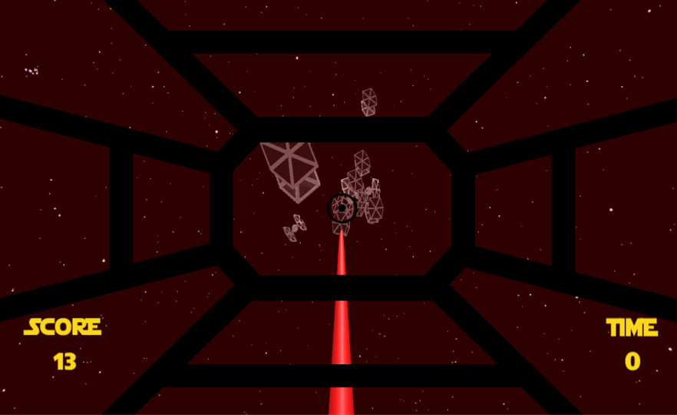

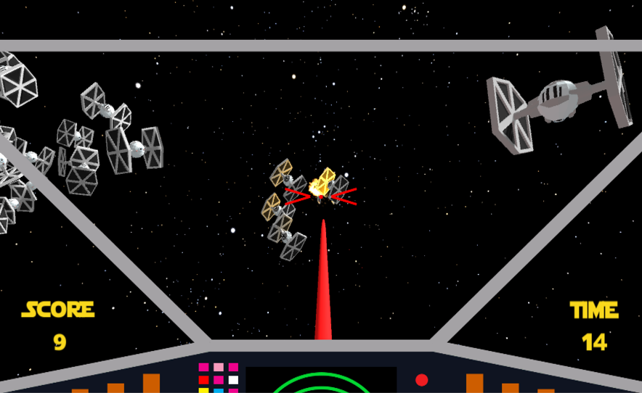

Players

Player Character

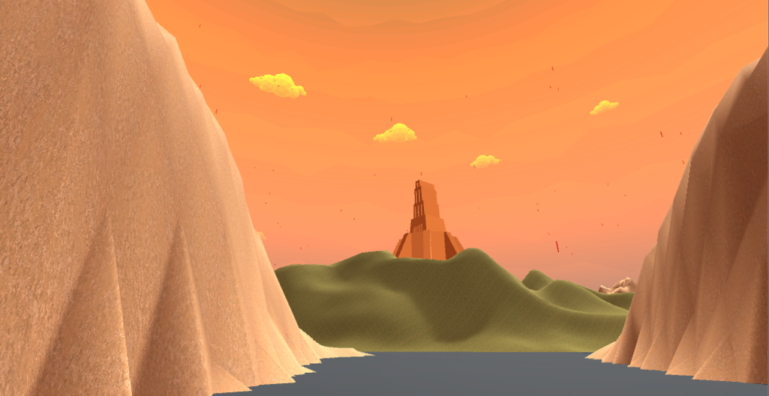

The player is in a first-person environment playing as a star pilot making their way through rugged terrain to their base to board their star fighter.

Player States

Idle: The player will simply remain still and have the ability to look around

Move: The movement during the ground gameplay is basic W A S D movement with the ability to look around using their trackpad or mouse with the handy ability to jump

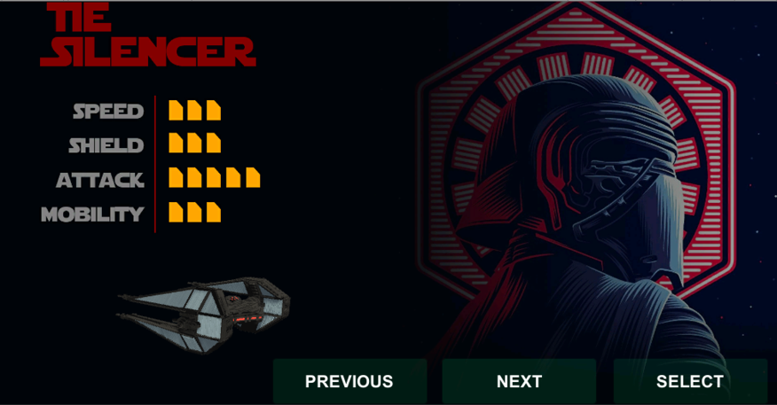Art

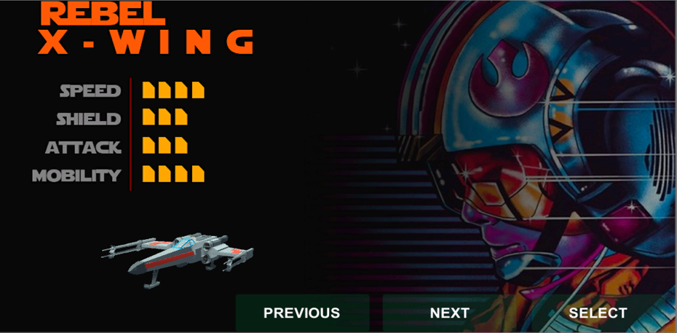

Setting

The game takes place on the planet of Yavin 4 where the enemy has come out of hyperspace to attack the friendly planetary base housing your star fighter. The player has to run through a hail of laser fire and the enemy ATST walkers and get to the large temple that is housing a loading dock full of star fighters, and more importantly your star fighter.

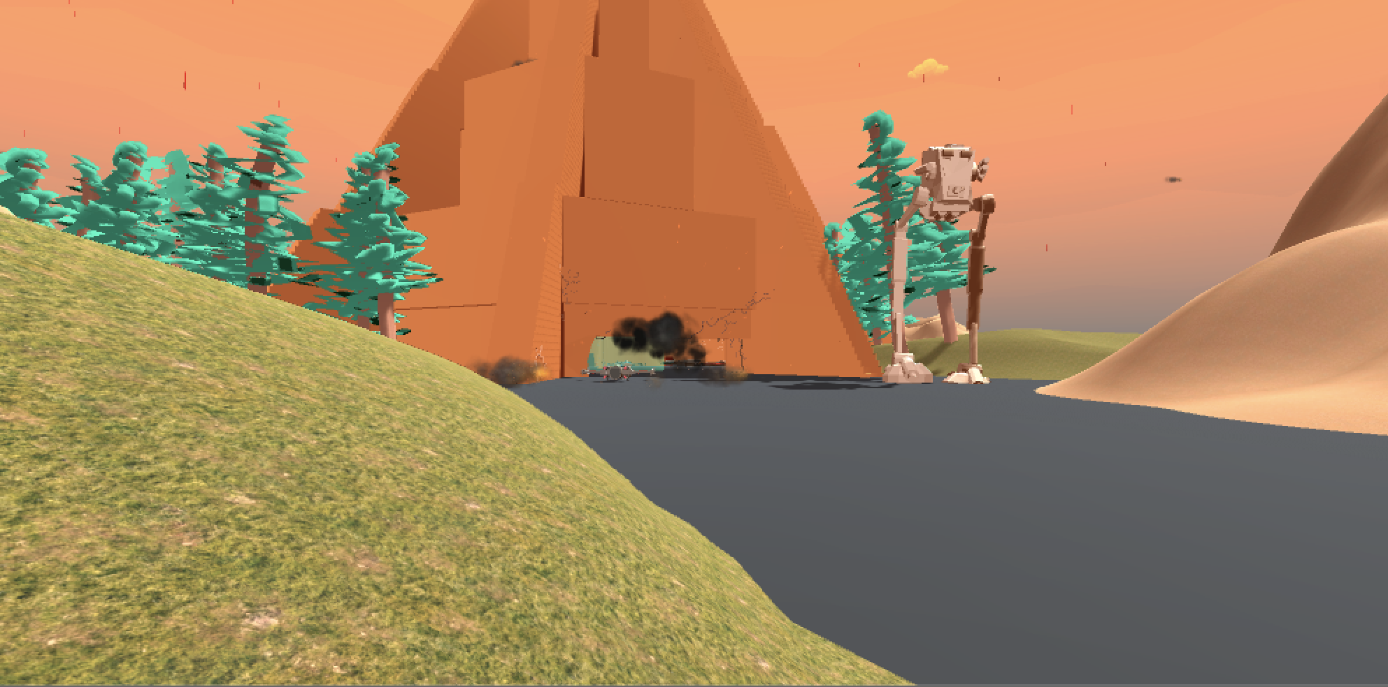

# 

Level Design

The level design consists of what can be considered as two different levels, the primary ground level and the secondary space level. The primary level is a large piece of terrain with object in the middle of the map and the secondary level the player is placed in the cockpit of their ship and the shooting mechanic is almost that of a stationary turret where the player can look around for enemy targets and fire.

Minimum Viable Product

* 3 different characters and ships to choose from
* Built for Mac OS platform
* Two levels (ground and space)
* Single timed game mode
* Basic rendering optimization

Wishlist

* Cross Platform builds – iOS is the first goal
* Several levels in space
* Different planets
* More detailed and responsive terrain